Design of Betsy Ross Flag – Jacob Bollinger

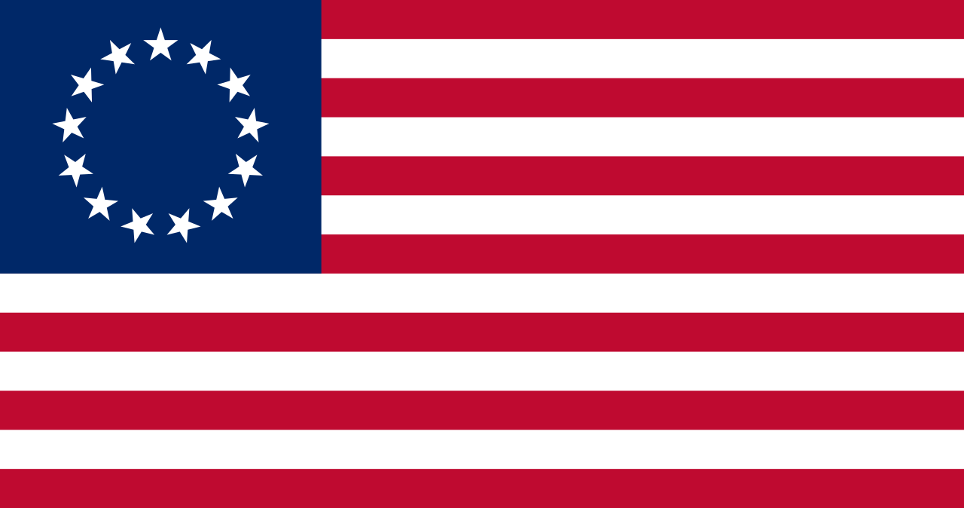

The Betsy Ross flag has 7 red stripes, 6 white stripes, a blue rectangle, and 13 white stars in a circle. I first need to define the constants RED, BLUE, WHITE, SIZE, WIDTH, HEIGHT, RADIUS, and TITLE. I then need to create the function fillRectangle() to draw and fill rectangles. Then I need to use trig to create fillStar() to draw and fill the star. Next is to define the screen and turtle variables so I can see the flag and turtle can draw it. Finally us the fillRectangle() and fillStar() functions to create the flag.

The fillRectangle() code needs to tell turtle the pen color then tell turtle to go to the upper left corner. Then tell turtle to start filling the color and to go to the lower left corner, lower right corner, upper right corner, and finish in upper left corner.

The fillStar() function is more complicated. First you will tell it to find 5 points on a circle with equal distance between. From there find the point where 2 lines through 2 points each intersect. Use this to create another circle inside the previous. Find 4 more points on the inner circle to have 5 points equally separated on it. Now tell turtle to connect all 10 points in the order that will create a 5-point star and fill it with the chosen color.

The circleOfStars() function is a little less complicated. First you will tell it to find 13 points on a circle with equal distance between. Then create a for loop to tell turtle to draw a star on each of the 13 points in white.

The next thing to do is to create the screen variables. These will create a screen to display the flag. Create a for loop to go from the origin and create 3 full length stripes of red. Create a for loop to go from the lowest red stripe and create 3 full length stripes of white. Tell turtle to go up 6/13 of the height up and right the width of the union. Then tell turtle to draw 4 red stripes with length of the width of the flag minus the width of the union. Tell turtle from the origin to 7/13 of the height up and right the width of the union. Then tell turtle to draw 3 white stripes with length of the width of the flag minus the width of the union. Next tell turtle to go up the height of the flag and create a blue rectangle right with the width and height of the union. Tell turtle to go from the origin 9.5/13 of the height of the flag up and half of the width of the union left. Then tell turtle to draw circleOfStars() in white.